NAME: MUSYOKI BENEDICT NGATHIKE
REGISTRATION NUMBER: C025-01-0834/2022
COURSE: BACHELOR OF SCIENCE IN INFORMATION TECHNOLOGY
UNIT: CAPSTONE PROJECT
TASK: PHOTOGRAPHIC ESSAY

Photographic Essay: Access to Clean Water in African Communities

Introduction
Water is life, yet millions of people across African communities face daily struggles accessing clean and safe water. This photographic essay highlights the challenges faced, the impact of unsafe water, and the transformative effect of sustainable solutions. Through these images, we explore how water scarcity affects health, education, gender equality, and economic development, while also showcasing community-driven initiatives aimed at creating lasting change.

Photo 1: Daily Journey for Water

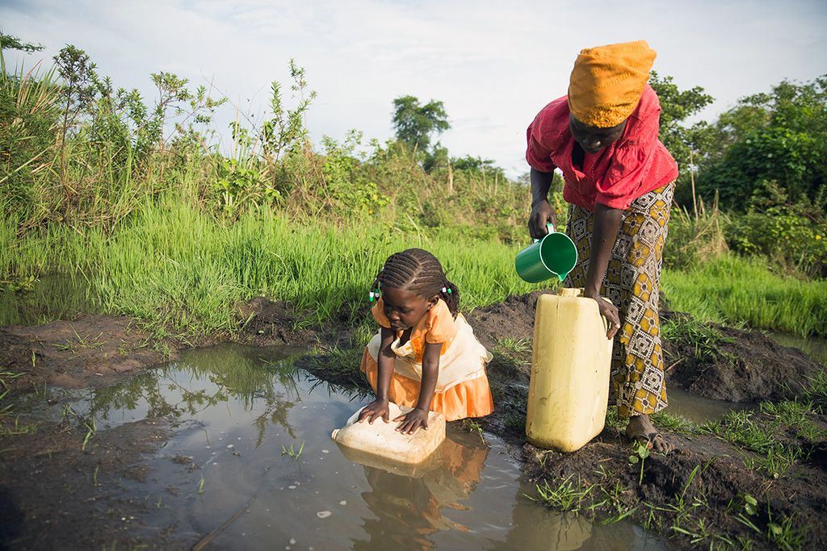
Caption: "Every day, women and children in some communities walk miles to fetch water, often from unsafe sources."
Insight:
In many villages, water points are located far from homes. This daily journey not only consumes valuable time but also exposes families to exhaustion, security risks, and missed opportunities for education and economic productivity.

Photo 2: Water Collection and Storage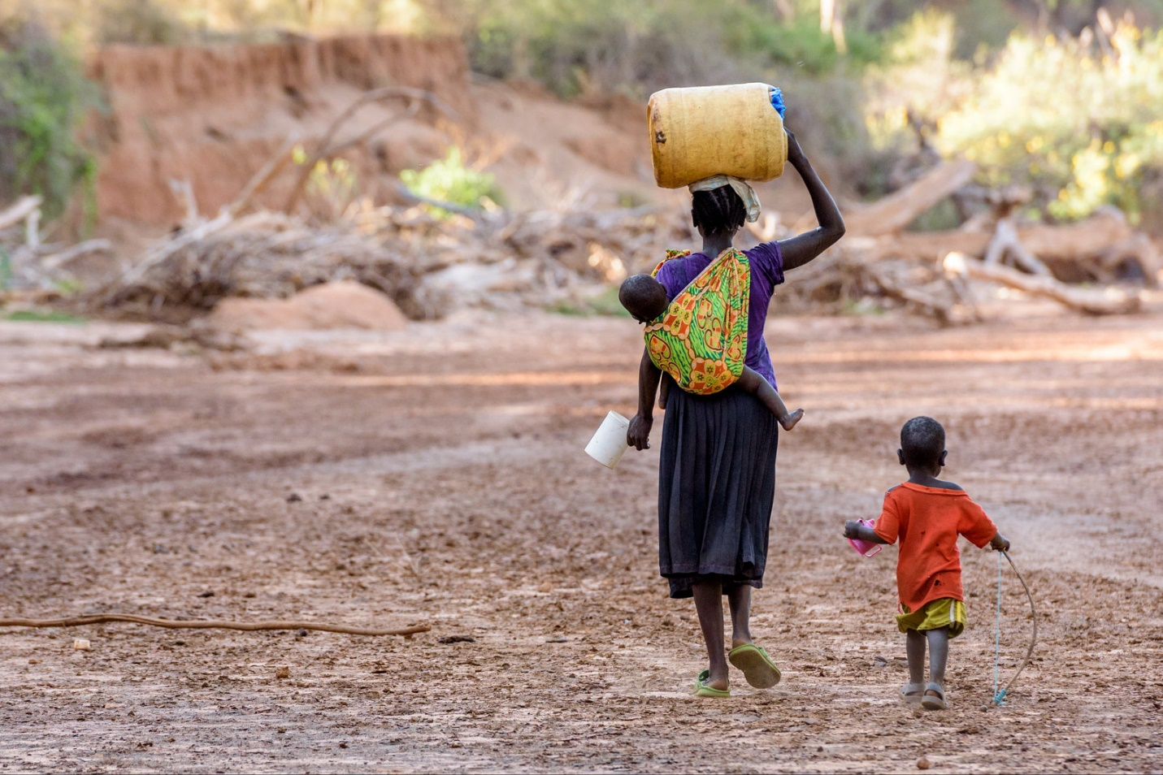

Caption: "Water collection is a daily chore, with families gathering water in containers for use throughout the day."
Insight:
Because access is limited, households must carefully ration their water for cooking, cleaning, and drinking. Poor storage methods often expose water to contamination, increasing health risks despite the effort invested in collecting it.

Photo 3: Water Quality Issues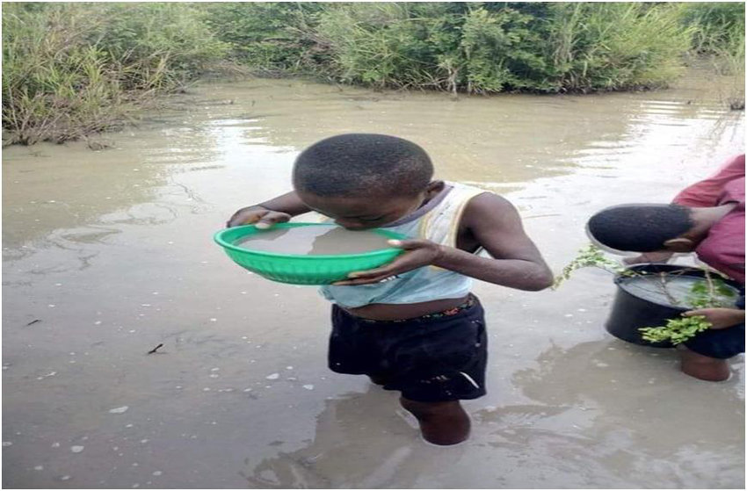

Caption: "Many communities depend on contaminated water sources, leading to outbreaks of waterborne diseases."
Insight:
Without proper infrastructure or filtration systems, communities often rely on rivers, ponds, or shallow wells shared with animals. This leads to the spread of diseases like cholera, dysentery, and typhoid, placing immense pressure on healthcare systems.

Photo 4: Impact on Health
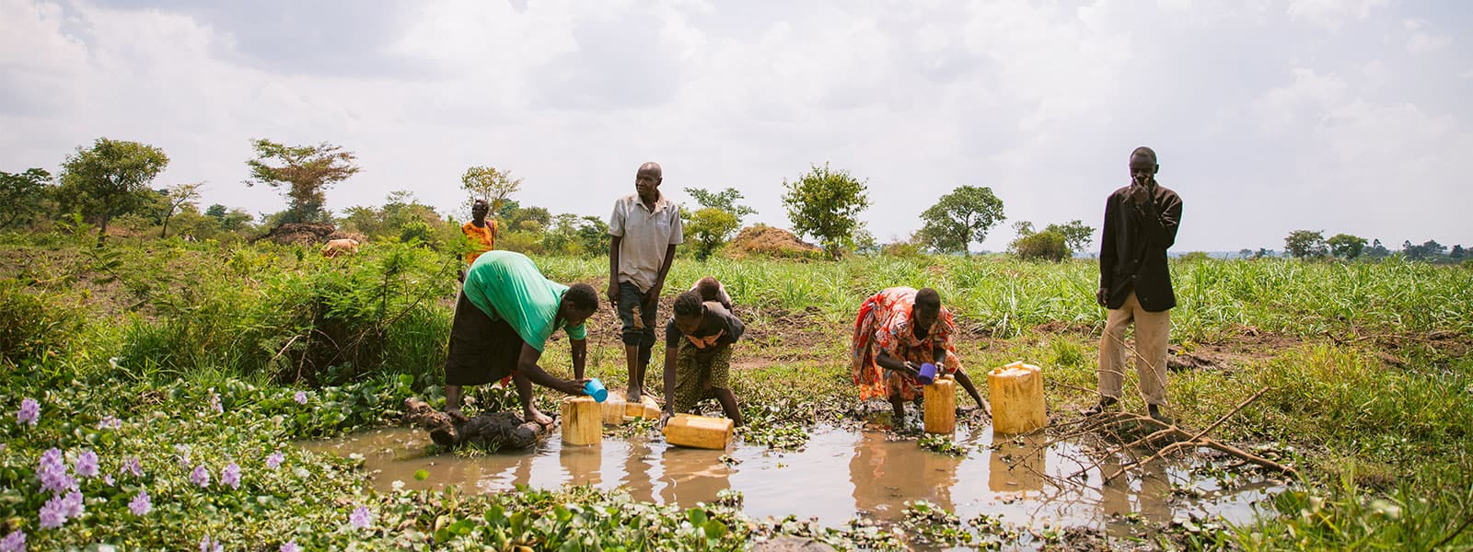
Caption: “Unsafe water contributes to widespread waterborne diseases, particularly affecting children and vulnerable populations.”
Insight:
Water-related illnesses reduce life expectancy and hinder community development. Malnourished and sick children miss school frequently, perpetuating cycles of poverty and limiting future opportunities.

Photo 5: Community Initiatives
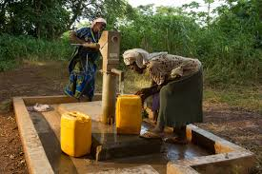

Caption:
"Community-driven projects focus on providing safe water, promoting better health, and enhancing sanitation."
Insight:
Grassroots initiatives are crucial in bridging gaps left by inadequate infrastructure. By installing boreholes, rainwater harvesting systems, and water treatment facilities, these programs improve health and empower communities to take ownership of their development.

Photo 6: Women and Water Empowerment

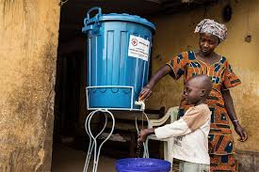

Caption:
"Access to clean water empowers women, granting them more time for education, entrepreneurship, and leadership roles."
Insight:
In many rural settings, women bear the greatest burden of water collection. When clean water becomes accessible, they gain freedom to pursue education, participate in economic activities, and contribute to decision-making in their communities.

Photo 7: Sustainable Solutions
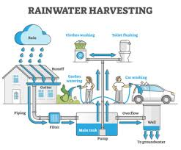
Caption:
"Sustainable water projects, such as solar-powered pumps and rainwater harvesting systems, transform lives and foster long-term community development."
Insight:
Investment in sustainable infrastructure is critical for lasting change. By combining modern technology with local knowledge, these projects ensure continuous access to clean water while addressing environmental and economic challenges.

Conclusion
Access to clean water is not merely a basic human right — it is a foundation for health, education, gender equality, and economic development. The photos presented illustrate the urgent need for investment in sustainable water solutions.

Key Takeaways
- Health Improvement
- Clean water reduces waterborne diseases like cholera and typhoid.
- Improved sanitation leads to stronger, healthier communities.
- Educational Benefits
- Children, especially girls, spend less time collecting water and more time learning.
- Proper hydration enhances concentration and academic performance.
- Economic Growth
- Families save time and energy, enabling engagement in income-generating activities.
- Reliable water access boosts agricultural productivity and food security.
- Gender Equality
- Women gain time for education, employment, and leadership roles.
- Reduced physical strain improves their overall well-being.
By highlighting these challenges and solutions, this photographic essay underscores the need for collaboration between governments, NGOs, and local communities to secure universal access to clean, safe, and sustainable water sources.

